**Software Requirement Specifications for Project**

**Q&A website**

**Version 1.0**

**Approved**

**Prepared by:**

DEEPTHI POTHINENI

BINDU JAMMULA

KEERTHI CHINTA

SAISREE GUMMADI

VISHWANATH REDDY RAMAYYAGARI

SURVI VIDIT DATTA

CHANIKYA DEVARAPALLI

SHIRIDI CHAITANYA SANDHYALA

Date Created: 09-30-2021

**Table of Contents**

1. Overall Structure of the System.......................................................................................................................................................... 2

1.1 Diagrams………………............................................................................................................................................................................... 2

1.2 Descriptions about System Structure.............................................................................................................................................3

2. Requirements Specifications................................................................................................................................................................3

2.1 Functional Requirements..........................................................................................................................................................………3

2.2 Non-Functional Requirements...............................................................................................................................................……... 3

2.3 Interfaces................................................................................................................................................................................................... 4

2.3.1 User Interfaces..................................................................................................................................................................................... 4

2.3.2 Hardware Interfaces................................................................................................................................................................……… 4

2.3.3 Software Interfaces............................................................................................................................................................................ 4

2.3.4 Communications Interfaces........................................................................................................................................................... 5

3. Plans for Developments Phases......................................................................................................................................................... 5

3.1 Development Phase 1………………………………………………………………………………………………………………………………….... 5

3.2 Development Phase 2………………………………………………………………………………………………………………………………….... 5

3.3 Development Phase 3………………………………………………………………………………………………………………………………….... 5

4. Member Roles & Contribution …………………………..…………………………………………………………………………….…………….. 6

**1. Overall structure of system:**

The primary motive behind this project is to connect various individual minds in the community. This project will provide a platform for the users to post their queries, express their opinions as well as view what is being posted in the community. This platform hosts information on numerous topics such as health, education, technologies, entertainment and other trending topics. Users can comment on posts from their expertise or personal experience. Although there are certain sites already catering to these needs we intend to develop a more enhanced version with a better user friendly interface.

User interface is developed by using HTML, CSS, bootstrap and JavaScript.

By using php we merge the user interface with MySQL database via XAMPP server.

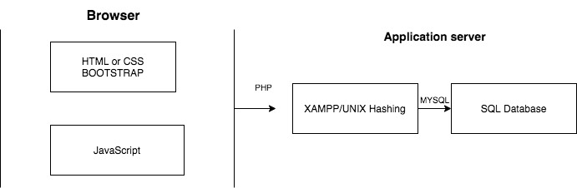

The main feature of the end product is to enable users to login, browse homepage, post and view what is being posted.

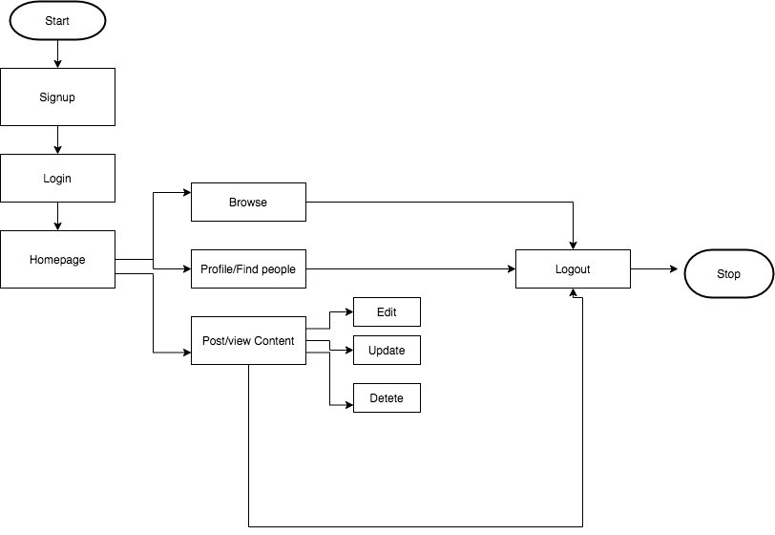

**Signup:**

Initially, the user needs to provide some basic details to register which are then stored in the User database.

**Login:**

Once the users sign up, they will be able to login anytime and can explore the homepage.

**Homepage:**

The user can browse the homepage which hosts numerous posts. Homepage provides an ability to check other user profiles or find new people.

**Post/view content:**

Users can put forward his/her queries in the form of posts. Users can also look at what other users are posting and answer them as well.

**Edit/Update/Delete:**

The user is provided with the capability to edit, update and delete any content (such as posts, comments) he/ she posted in the website at any time.

**Logout:**

User can log out securely after he uses the website for his needs.

**2. Requirements Specifications:**

**2.1. Functional requirements:**

**Authentication Requirements:**

* The system must allow users to log into their accounts by using their mail and password.
* The system must send confirmation mail whenever the user is signed up.
* Users can able to change their password by clicking ' forgot password' and receiving the link to the verified email address.

**Authorization Requirements:**

* Only authorized user can update, edit or delete their content.
* Audit tracking
* Tracking of the system users by using Google analytics.

**2.2. Non-Functional requirements:**

For non-functional requirements we thought concentrating working on real time problems.

**Maintaining Database:**

* Backing-up Database from time to time.
* If any server crash occurs then all the user data must be backed-up without any loss.

**User Security:**

* Encrypting user password such that no one can access it.
* Only authenticated user can do updates on their profile.

**User Flexibility:**

* Must work on any display with all resolutions.
* Even if user submitted with any network issues it should be submitted properly.

**2.3. Interfaces:**

**2.3.1. User Interfaces:**

1. We are developing a user-friendly Question and Answer website with the best user interface, user can directly access the website, and feasible to use with attractive UI using the latest technologies.
2. The first page is the login page where a user can log in with his credentials, or if they are new users they can also sign up to authenticate their credentials.
3. On the Sign-up page we have input fields like FIRST_NAME, LAST_NAME, EMAIL, PASSWORD, DATE OF BIRTH, GENDER, and COUNTRY. Here FIRST_NAME, LAST_NAME, EMAIL, PASSWORD, and DATE OF BIRTH have asterisk fields.
4. After successful login we can enter into the home page, wherein header section we can see home page - which links or redirect to the home page when we are on another page, Profile page, Find people page, more (Drop-down) we can see my posts' section, Edit my profile section, About website page, Contact-us section, etc. logout button we can directly logout from the page, Search bar we can search the keywords so that it can crawl the content in the website page.
5. As we already discussed the home button it will redirect to the home page. When we are on another page.
6. Profile page, it consists of one banner image and one profile image and the information about the user like user name, country, date of birth, Status, gender, etc.. And it also displays the posts which are posted previously by the user.
7. Find people page, it consists of the list of the user who is already signed up for the website and also we can search the users using search bar so that we can view their profile and their previous activities.
8. More dropdown, in this dropdown, we have my posts- we can see our activities, edit my profile- in this, we can edit our personal information which we have given while signing up for the website, About page- this page shows the detailed description about the website to the user and there will be privacy and terms pages in this dropdown.
9. We have a logout option on the right side of the header which can be used to session out the page and redirects to the login page.
10. In the search option we can search the information related to the website using the keywords.
11. On the home page, we have a text box where we can write our content and post, and also we can attach images.

**2.3.2. Hardware Interfaces:**

* Monitor : 1024*768
* Processor : Intel i5
* RAM : 8GB

**2.3.3. Software Interface:**

* XAMPP 1.8.0, Apache web server 2.4.2, Control panel.
* Database Server : MYSQL database
* Developing languages : HTML, CSS, JavaScript, PHP

**2.3.4. Communication Interfaces:**

* HTTPS is used for system connectivity.

**3 Development Phases:**

**3.1. Development phase 1:**

* User Interface- Home Page (welcome page)
* User Interface- Authentication Page (login/signup page)
* Data Model Creation
* User Database Linking

**3.2. Development Phase 2:**

* UI- creation of headers, body and footer pages
* UI- adding the text box and image posting features
* Checking the Data flow- whether the data is updating in a database or not.
* Extracting the data from the database using php and MySQL functions.
* Alignment of the data.

**3.3. Development Phase 3:**

* UI- Adding features like edit, delete and update
* UI- Adding read more options for the content word limit using JavaScript.
* Adding session codes.
* Testing.
* Bug fixing.
* Re Evaluation.

**4. MEMBER CONTRIBUTION TABLE:**

|  |  |  |  |
| --- | --- | --- | --- |
| Member name | Contribution description | Overall Contribution (%) | Note  (if applicable) |
| DEEPTHI POTHINENI | Backend Developer, Documentation | 17% |  |
| BINDU JAMMULA | Requirement Gathering, Testing | 12% |  |
| KEERTHI CHINTA | UI Developer, Documentation | 12% |  |
| SAISREE GUMMADI | UI Developer, Presentation | 11% |  |
| VISHWANATH REDDY RAMAYYAGARI | Database, Documentation | 12% |  |
| SURVI VIDIT DATTA | Backend Developer, Presentation | 11% |  |
| CHANIKYA DEVARAPALLI | Backend Developer, Testing | 12% |  |
| SHIRIDI CHAITANYA SANDHYALA | Database, UI Developer | 13% |  |